November 17, 2025
Hitanshu S. Bhatt - 000367185
Harpreet kaur

Text- analyzer
assginment 2
Introduction

This text-Analyzer is a react based web application that provides real-time analysis functionality. The application counts sentences with the help of periods(.) and also calculates word frequency distribution based the text inputted by the user. This web- application was built with react version 18.2.0. This project demonstrates basic text processing algorithms and modern react development practices.

Project Overview
This Text-analyzer application allows users to analyze text content by providing:-
- Sentence count determined by periods(.)
- How many times a word appears in the text
- Clean and easy to use user interface
Technology Stack
Below are the technologies used for each component:
Component | Technology
Front-End Framework | React
Build Tool | React-Scripts
Testing Framework | React Testing library
Language | Javascript
Styling | CSS

Project Structure
Below is the screenshot show the basic project layout:-
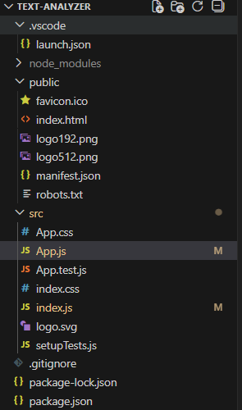
Feature Specifications and Code Implementation
Text Input
- Component:- The Text Area with controlled input
- Validation:- non excepts any text
- Resize:- allows user to resize text box vertically
Application Code
Main Application Component (app.js)
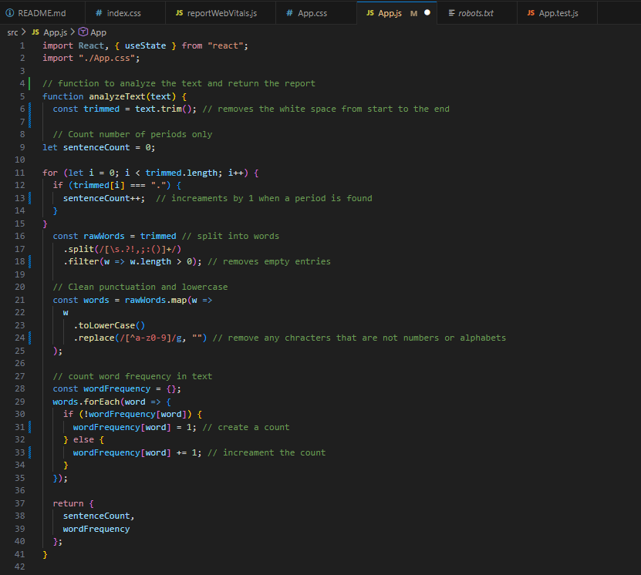
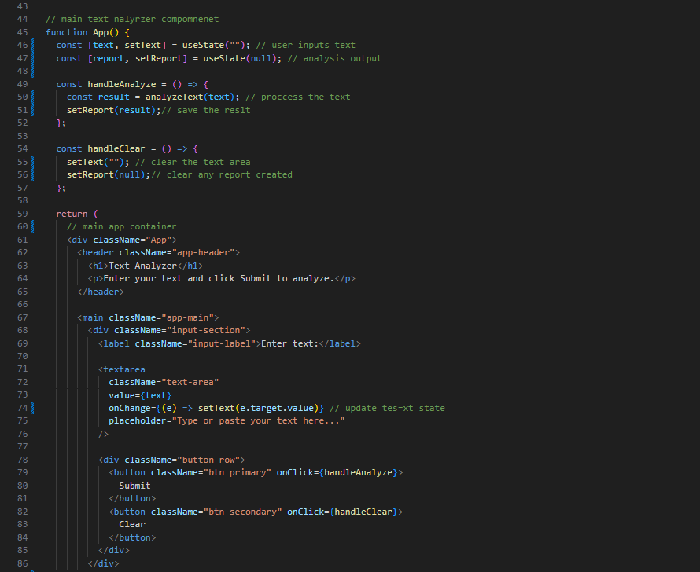
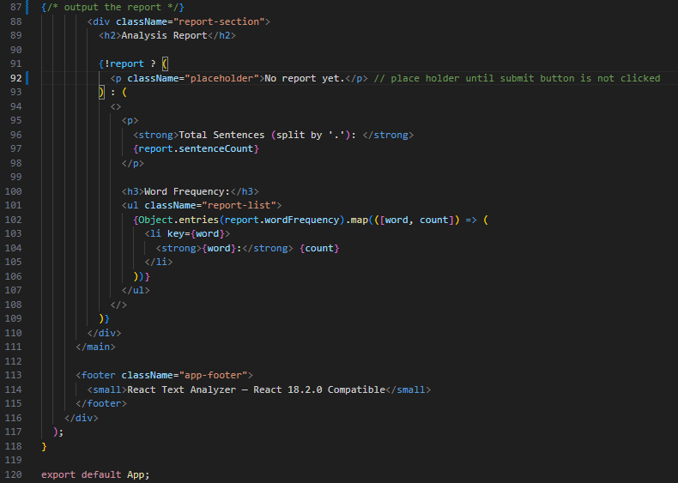
The Screenshot above shows the App.js file that contains the following :-
- The import statements of React and CSS
- How analyzeText() function was implemented
- The main App component with the state management
- Complete JSX structure including header, input section, report section, and footer
Analysis Algorithm Breakdown
Sentence Counting Logic
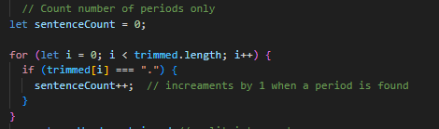

Key Points:
- Iterates character by character through trimmed text
- Increments counter when period (.) is found
Limitations:
- Only counts periods (ignores '!', '?')
- No sentence boundary detection logic
- Doesn't handle abbreviations (Dr., Mrs., etc.)
Word Frequency Analysis
Process Flow:
- Split text by whitespace and punctuation using : (/[\s.?!,;:()]+/)
- Filter empty strings from the resulting array
- Convert each word to lowercase for case-insensitive counting
- Remove non-alphanumeric characters using: (/[^a-z0-9]/g)
- Count occurrences using a frequency map object
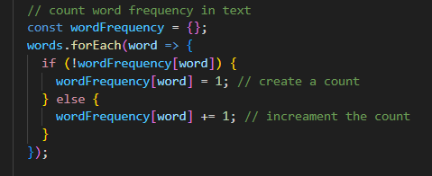
Screenshot above shows how the program counts words using an If statement
Application Styling (App.css)
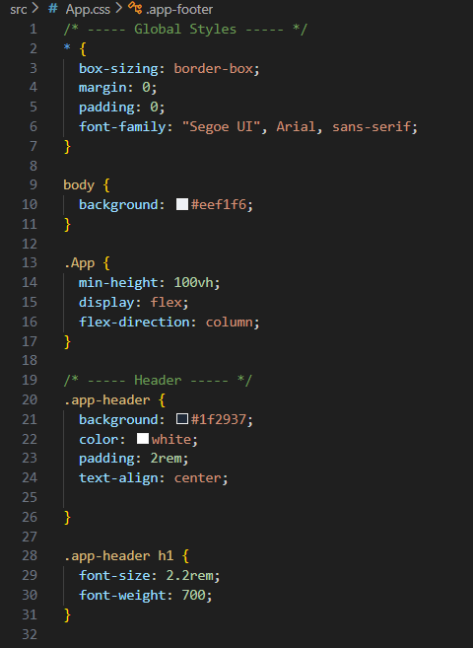
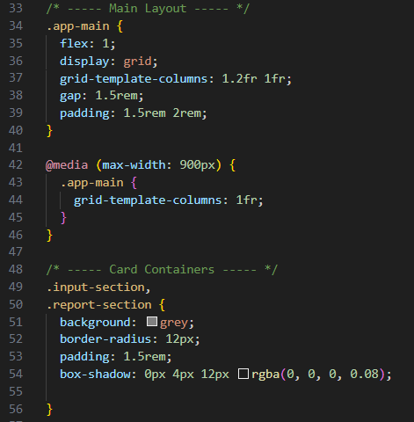
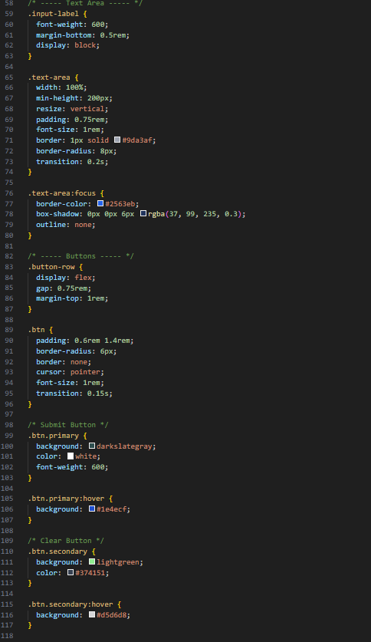
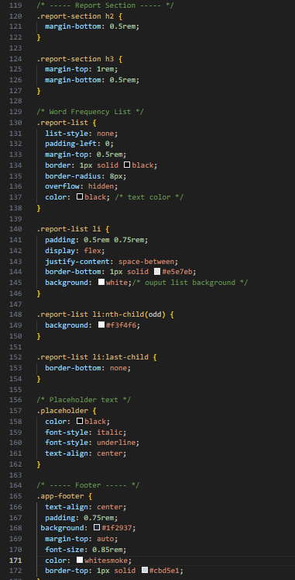

The screenshot above displays the complete styling file showing:
- Global CSS and base styles
- Header and footer styling
- Grid layout system for main content
- Input section and text area styles
- Button styles (primary and secondary)
- Report section and list styling
- Responsive media queries
- Hover and focus states
User Interface Design
Color Scheme
- Primary Background: light gray
- Header/Footer:dark gray
- Primary Button: darkslategray with hover effect
- Secondary Button: lightgreen with hover effect
- Text: Black on white/gray backgrounds
Layout Structure
- Grid System: 1.2fr (input) / 1fr (report)
- Responsive Breakpoint: Single column below 900px
- Padding: Consistent spacing (1.5rem - 2rem)
- Border Radius: Modern rounded corners (8px - 12px)
Interactive Elements
- Hover states on buttons
- Focus states with visual feedback
- Vertical text area resizing

Entry Point (index.js)
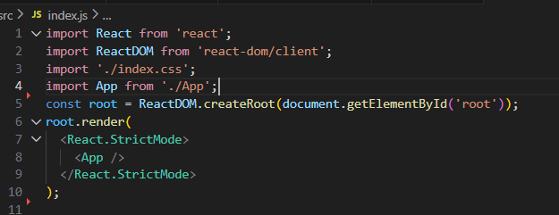This screenshot shows:
- React and ReactDOM imports
- CSS imports
- App component import
- Root element creation using React 18 API
- StrictMode wrapper

Test Cases
Test case 1 :-
This test case was carried out to ensure that the total sentences(separated “.”) does not increment without a period (.)
- input text “hi”
- expected outcome: - total sentences (separated “.”):0
  - word frequency “hi” should be “1”
below is a screenshot showing that this test case scenario is true
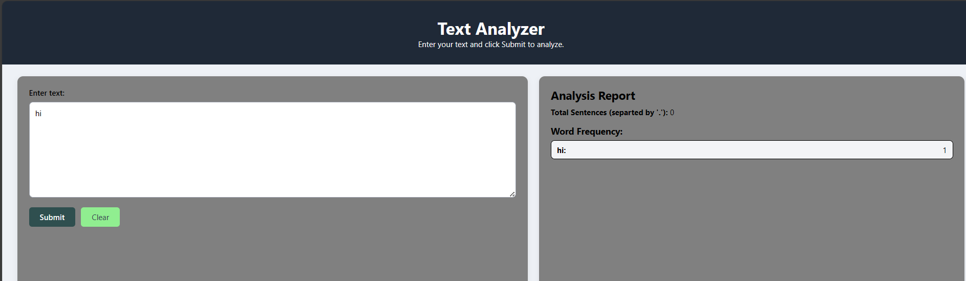

Test Case 2 :
This test case was carried out to ensure that the total sentences(separated “.”) increments by 1 as only one period(.) is present.
- Input text:- “hi.how”
- Expected Output : - Total Sentences(Separated by ‘.’) “1”
  - Word frequency “hi” should be “1”
    - “how” should be “1”
Below is a screenshot showing this test case is true
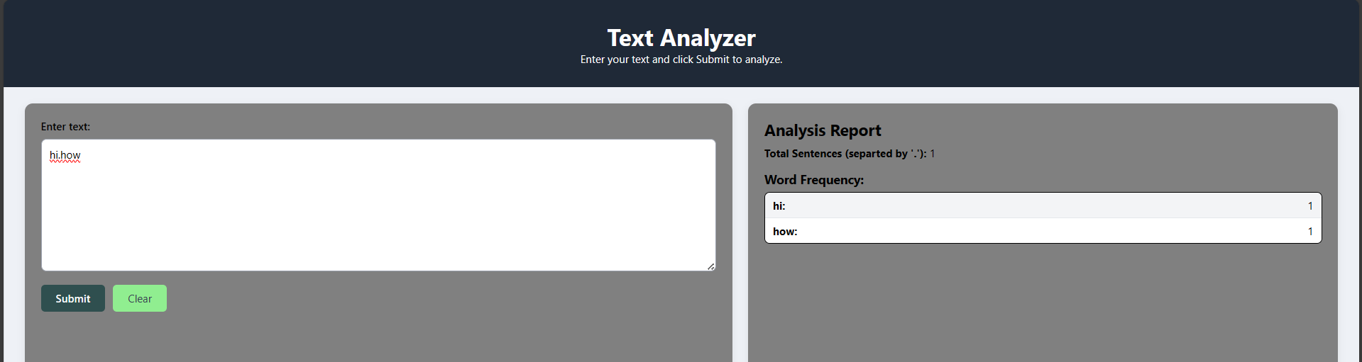
Test Case 3:
This test case was carried out to ensure that the total sentences(separated “.”) increments by 4 as four periods(.) are present.
- Input text:- “hi.how.are.you.today”
- Expected Output : - Total Sentences(Separated by ‘.’) “4”
  - Word frequency “hi” should be “1”
    - “how” should be “1”
    - “are” should be “1”
    - “you” should be “1”
    - “today” should be “1”
Below is a screenshot showing that this test case is true
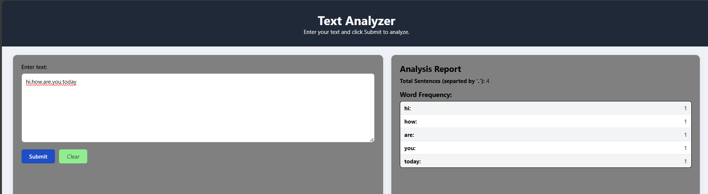
Test Case 4:
This test case was carried out to ensure that the word frequency increases by 1 as the same word is repeated once more.
- Input text:- “hi.hitanshu.hitanshu ”
- Expected Output : - Total Sentences(Separated by ‘.’) “2”
  - Word frequency “hi” should be “1”
    - “hitanshu ” should be “2”
Below is a screenshot showing that the above test case gave the expected outcome
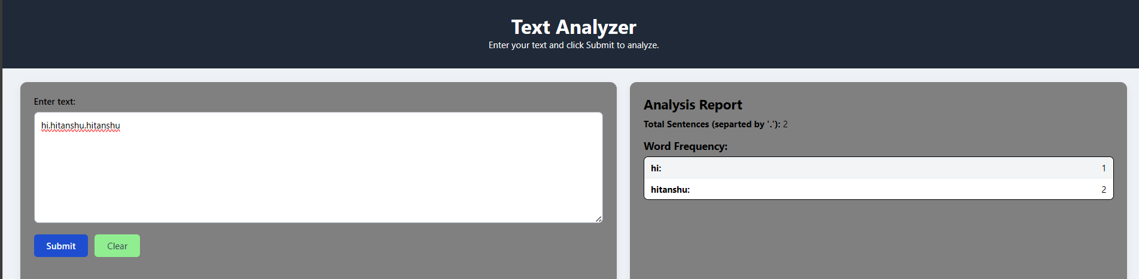

Test Case 5:
This test was carried out to ensure that the analyzer shows no word frequency and “0” for total sentences (separated by “.”).
- Input text:- “”
- Expected Output : - Total Sentences(Separated by ‘.’) “0”
  - Word frequency empty no data
Below is a screenshot showing that the above test case gave the expected outcome:
